# Project 2: Yard Sale

Yard sale is a web application that allows users to list items for sale as well as search for items through a simple easy to use web interface.

Yard sale will use node.js server with a mySQL database. We will be using multiple packages including Express, Jade, Sequelize. User authentication will be using firebase. Our styling will mainly be bootstrap and use page templating via Jade.

The database will hold multiple fields Item ID, Category of Item , Item Url, and Posted Date

Users will login, once authenticated they will have options across the menu. The users will be able to click “Buy” to see all listings in the app, “Sell” will allow for users to post a listing on the site, the search function will allow users to search the app database for items. Search results will be clickable and allow for me detail (Item Description, Item Image) to be seen by user.

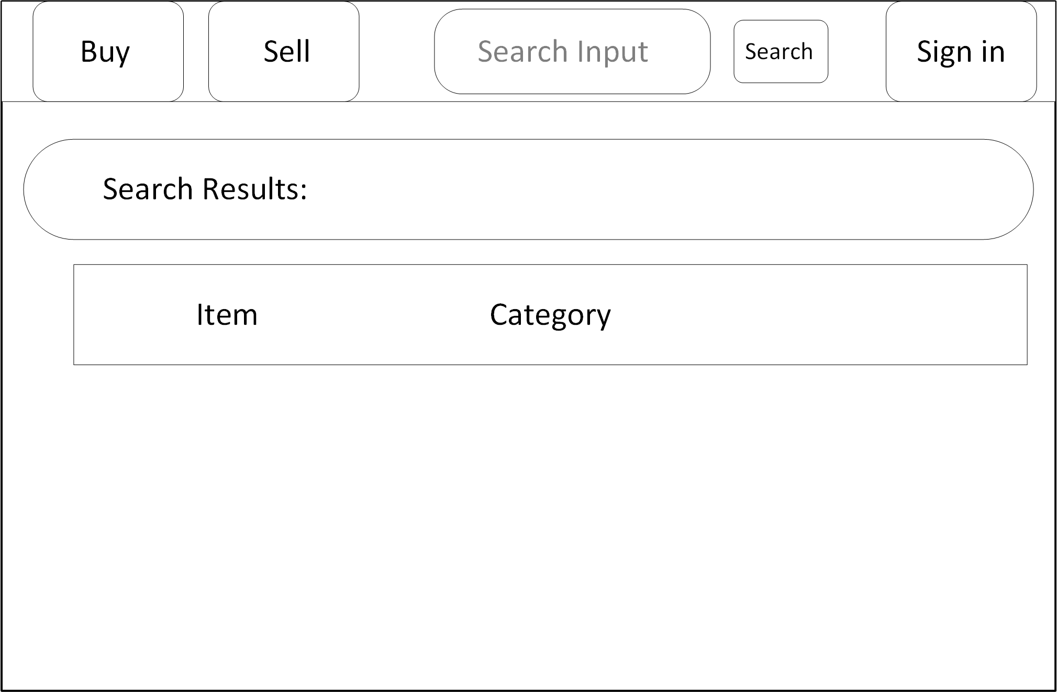



Users will login, once authenticated they will have options across the menu. The users will be able to click “Buy” to see all listings in the app, “Sell” will allow for users to post a listing on the site, the search function will allow users to search the app database for items.